

**CUSTOM-MADE BRIEF**

**March 15, 2021**

Contents

1. ABOUT MOD. 3

2. ABOUT THE EXHIBITION 3

3. OVERVIEW OF EXHIBIT 3

Concept 4

Visitor Flow 4

4. EXHIBIT ELEMENTS – DETAIL 5

Network map 5

Racing Platform 6

Vehicle Design Station 8

Vehicle Control Station 10

Leaderboard 15

# ABOUT MOD.

MOD. at UniSA is a futuristic museum of discovery. It’s a place to be and be inspired. We want to inspire young people about science and technology, showcasing how research shapes our understanding of the world around us to inform our futures. We design for 15 to 25 year olds, but our exhibits should inspire something in people of all ages.

MOD. is like no other museum experience in Australia. We sit at the intersection of art and science and we bring together researchers, industries, and students to challenge, learn, and be inspired.

MOD. provides free public access to all exhibitions and is currently wholly funded by the University of South Australia and limited donor support.

Please visit [mod.org.au/about/principles](https://mod.org.au/about/principles/) for the Vision and Design Principles of MOD.

# ABOUT THE EXHIBITION

**Exhibition:** It’s Complicated

**Theme:** Complexity and interconnectedness

**Summary:** The fifth exhibition at MOD. is a 9-month exhibition that focusses on *Dynamic Interconnectedness.* The exhibition aims to explore complex systems and the types of interactions between their parts or between a given system and its environment.

Examples of complex systems range widely, from the Earth's global climate, to the human body, to the future of manufacturing and the Internet of Things, to social and economic organizations (like cities), and are defined by distinct properties that arise from these system’s relationships, such as nonlinearity, emergence, spontaneous order, adaptation, and feedback loops.

**Keywords:** emergence, nonlinearity, adaptation, feedback, criticality, self-organisation, coevolution

# OVERVIEW OF EXHIBIT

**TITLE:** Custom-Made

**THEME / KEYWORDS:** Industry 4.0, autonomous vehicles, robotics, sensors, cloud computing

**CREDITS:**

* UniSA STEM – Concept, design and build
* REDARC – Funding
* Studio 1 Exhibitions – Build
* Exhibition Studios – Build
* Walls That Talk – Graphic design
* Lightbulb – Digital interface

### Concept

The aim of this exhibit is to provide visitors a highly interactive and engaging experience that provokes interest in the intricacies of Industry 4.0 and customer-led, autonomous manufacturing. The exhibit will incorporate networked communication, robotic assembly, camera localization and machine vision, data acquisition via sensors, and autonomous vehicle control.

Data recorded from multiple sensors on the robotic arms, the racetrack and the vehicles will be processed in real-time, providing a seamless experience of customer-driven manufacturing. These data will also be presented to visitors via an overall leaderboard.

This video demonstrates many aspects of the project and will give a good feel for what it is about: <https://www.dropbox.com/sh/8jflwb6luat3kzr/AADqeQept7-scW1_IhEjqbW2a?dl=0>

### Visitor Flow

1. Visitors begin at a touchscreen user interface on the *vehicle design station* where they will customise their vehicle (see below) by selecting from four vehicle types, four engine types and four power-ups.
2. The combination of selected vehicle elements is sent to the assembly area where a robotic arm will construct the vehicle. Once assembled, the vehicle will autonomously move to the starting line.
3. Visitors then move to the *vehicle control station* where they can then navigate their vehicle around the track once in a clockwise direction using joysticks and a power-ups activation button. This is aided by overhead and first person point-of-view (POV) real-time camera feeds.
4. Once the visitor’s vehicle crosses the finish line (same place as the start line), the vehicle will re-enter autonomous mode and move back to the robot assembly area where it will be disassembled. 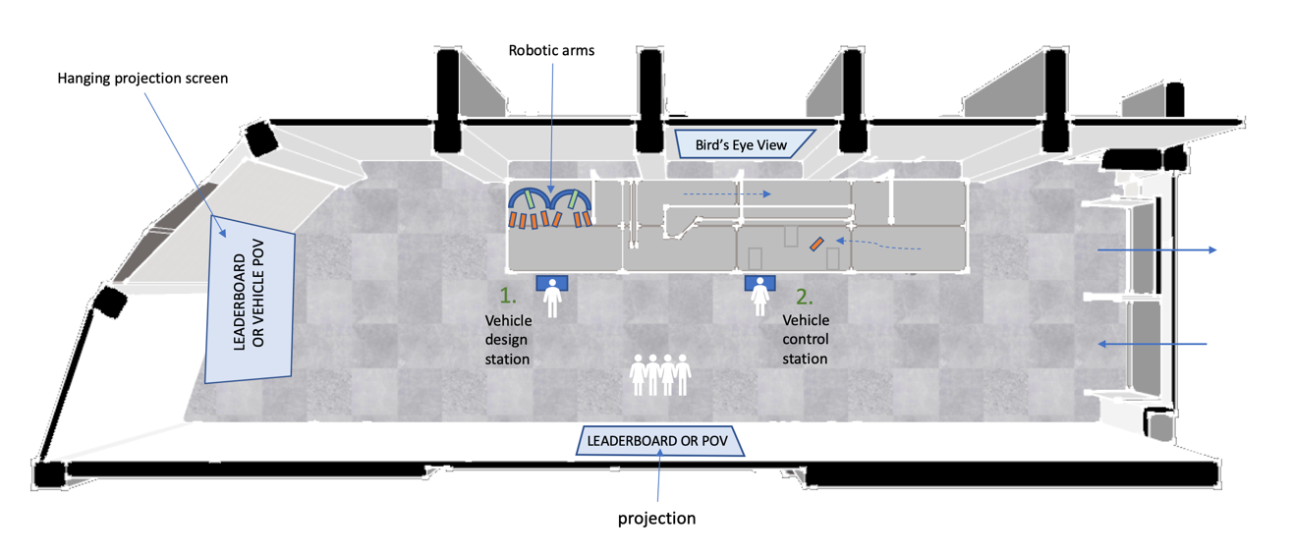

Throughout previous industrial revolutions, the work of humans has been augmented with machines in order to improve productivity, reduce workloads and operate in environments that are difficult or hazardous for people.

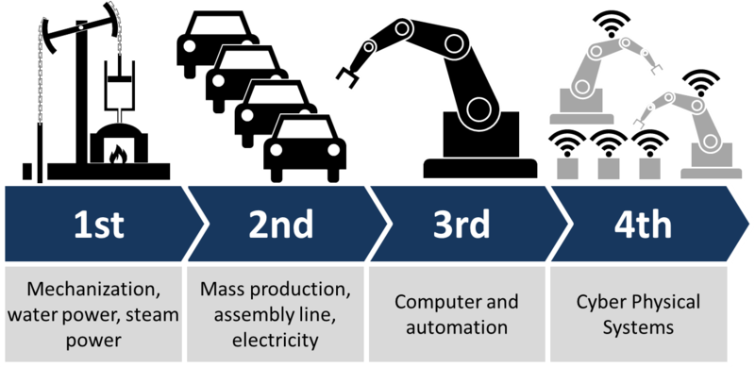

*The four industrial revolutions.*

The fourth industrial revolution (Industry 4.0) shares these ambitions by focusing on the integration of distributed smart control and communication systems using cloud computing and real-time data storage/retrieval.

# EXHIBIT ELEMENTS – DETAIL

## Network map



### Racing Platform

The main platform is 10 metres long and 2 metres wide and sits against the northern wall of the Arcade gallery. It is enclosed by a 1.5 metre high clear acrylic barrier on three sides to restrict visitor interference.

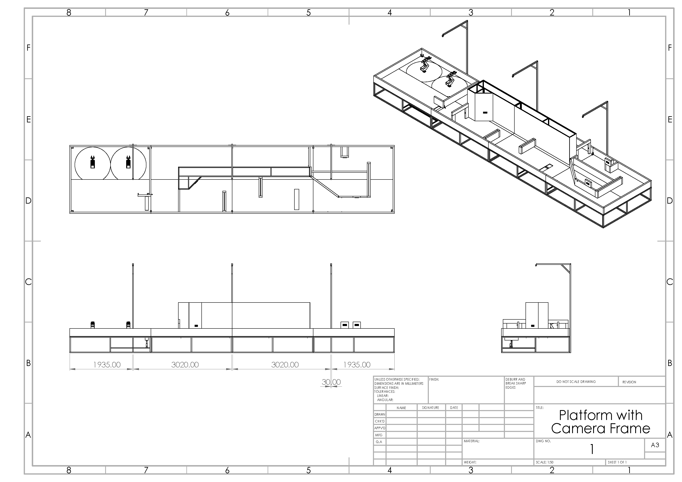

Within the platform are two main areas:

#### Robot Assembly Zone

This area houses the eight robotic vehicles (two of each type – see below) and the two Dorna robotic assembly arms.

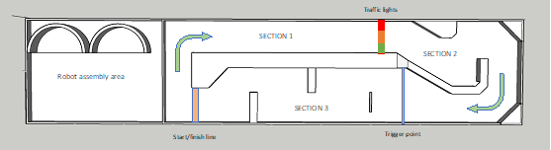

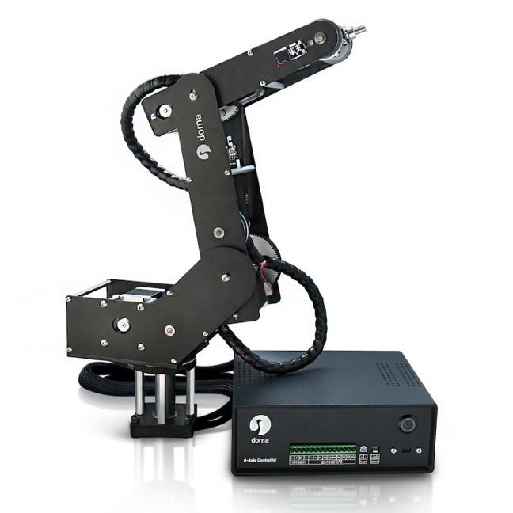

#### Testing Facility

This is the “racetrack” part of the platform where visitors get to race the vehicle they designed.



#### Safety Barrier

A safety barrier surrounds three sides of the entire platform. Two lockable doors at either end of the platform provide access for maintenance.

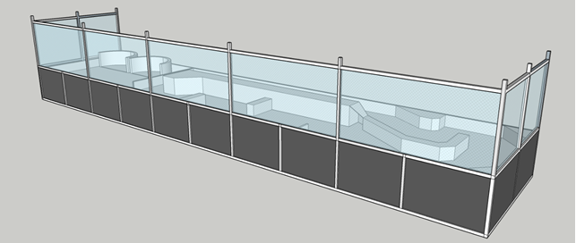

The barrier is constructed from an aluminium extrusion system and 6mm clear acrylic.

### Vehicle Design Station

The Vehicle Design Station is the starting point for engaging with the main exhibit. Here, visitors can select between four different vehicles, along with four different engines and four different powerups.

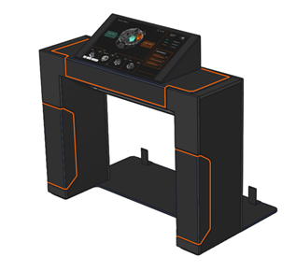

#### USER INTERFACE

Visitors interact with the user interface to select a type of vehicle chassis, engine and power-up.

### Vehicle Control Station

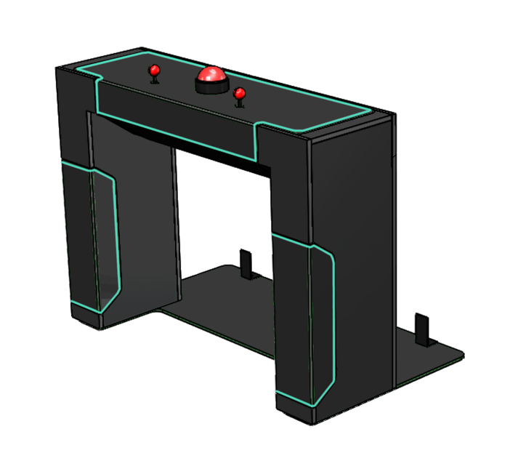

After designing their vehicle, and it has been assembled and autonomously driven to the start line, visitors will be directed to the Vehicle Control Station where they can take control.

The control station consists of two joysticks, a big red powerup button, and a monitor showing the vehicle’s point-of-view (POV) camera feed. Instructions for driving the vehicles and using the powerups are on the station itself.

#### Vehicle Control Station Instructions

##### Vehicle options

Each vehicle represents one of the four industrial revolutions. Each vehicle will have a particular steering method that will affect the way it is operated.

1. **Steam train** – First industrial revolution. The steam train steers with slip steering (wheels on one side rotate in one direction, while the wheels on the opposite side rotate in the opposite direction), allowing the train to turn on the spot. The point-of-view camera will be set to the side of the vehicle to reflect a train driver leaning out of the window.

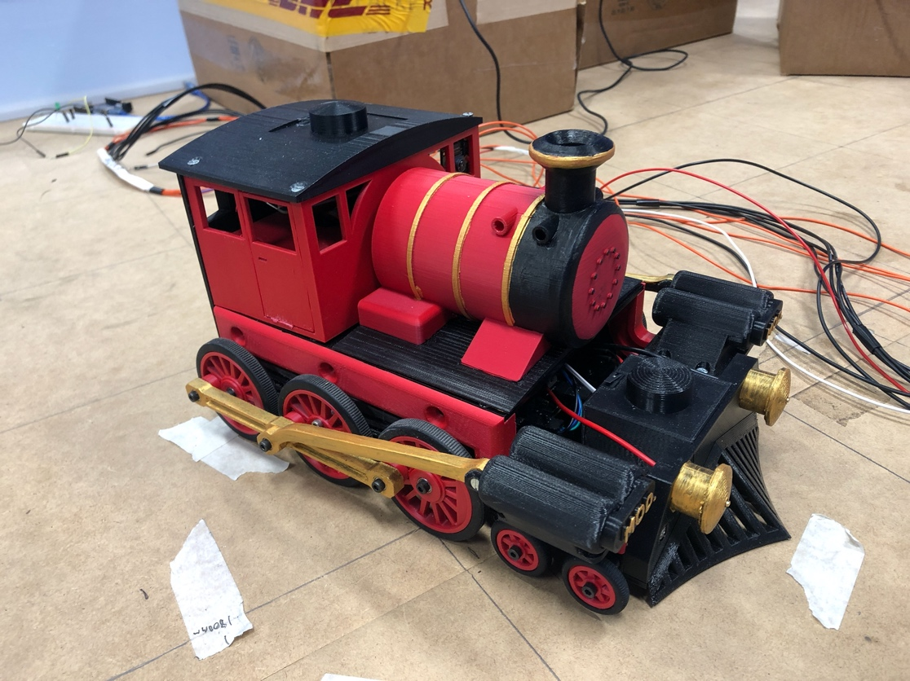

1. **Model-T Ford** – Second industrial revolution. The Model-T Ford will also steer by slip steering although will exhibit Ackerman steering behaviour.

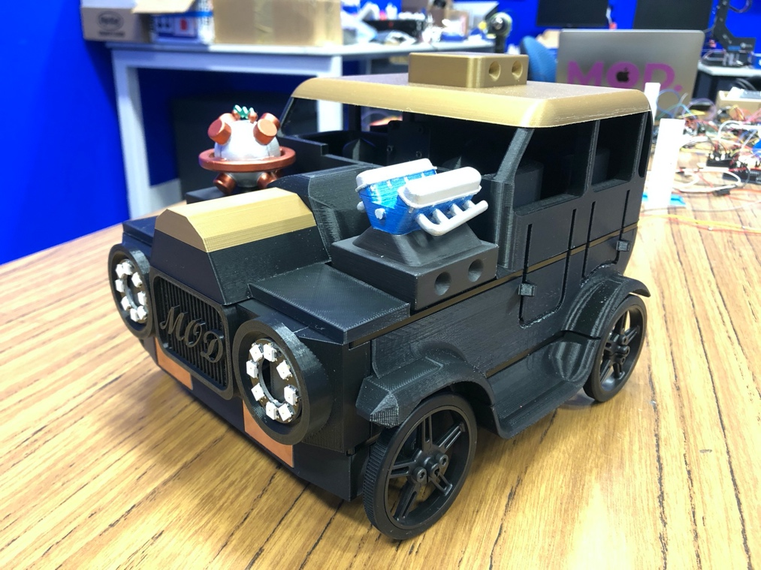

1. **Tank** – Third industrial revolution. The tank will also use slip steering (one track rotating one way, the other track rotating in the opposite direction).

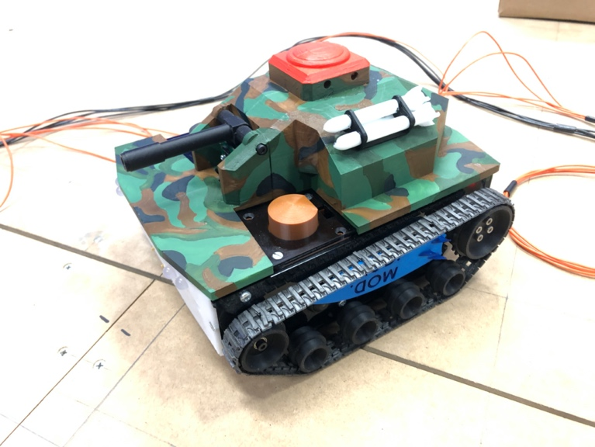

1. **Spaceship** – Fourth industrial revolution. The spaceship’s steering will be omnidirectional, meaning the vehicle can move in any direction, regardless of which way it is facing. The unique onboard camera will capture and display a 360° view.

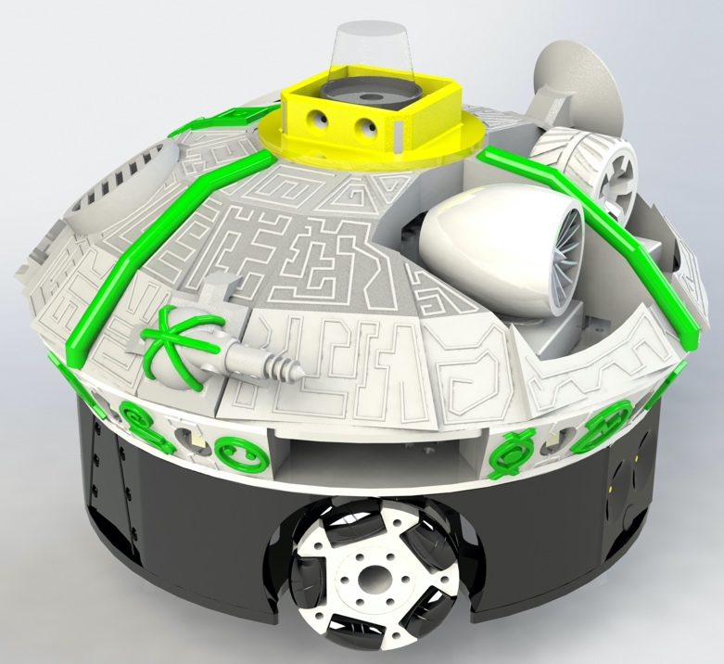

##### Engine options

Four engine types will also represent the four industrial revolutions. *Any of the four engines can be placed on any of the vehicles*, regardless of the industrial revolution they represent, e.g., the nuclear fusion engine can be placed on the steam train. Each engine is just 3D printed plastic, however the visitor’s choice will send ROS instructions on how each vehicle will behave programmatically.

1. **Steam** – first industrial revolution
2. **Petrol** – second industrial revolution
3. **Jet** – third industrial revolution
4. **Nuclear fusion** – fourth industrial revolution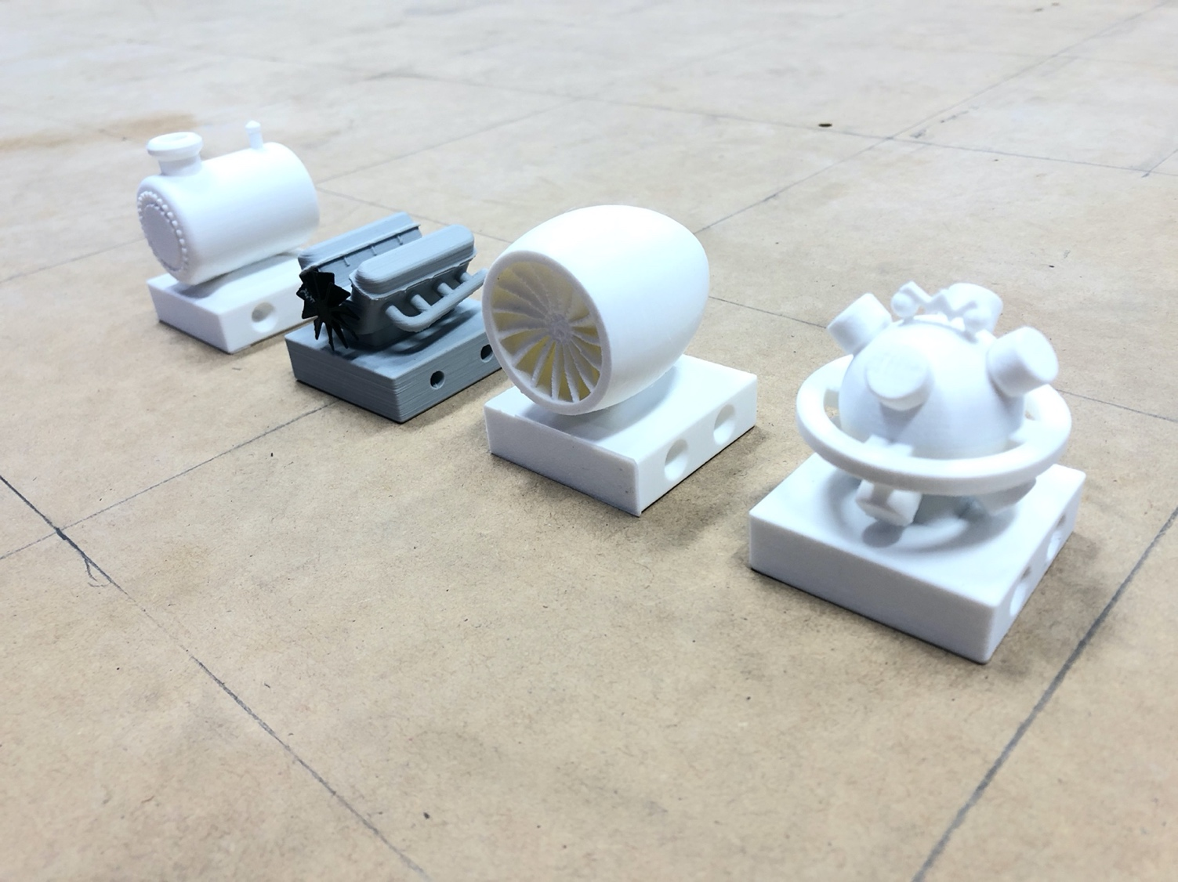

Petrol

Jet

Fusion

Steam

##### Power-up options

Power-ups are not related to the industrial revolutions. As with the engines, any of the four power-ups can be placed on any of the vehicles (in combination with any engine). The power-ups are activated with a big red button at the *vehicle* ***control*** *station.*

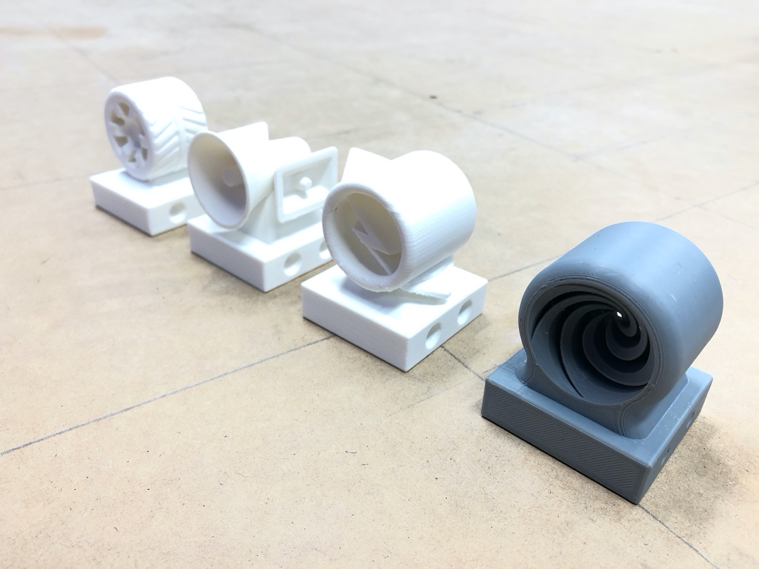

Short cut (portal)

Speed boost

Emergency

4WD

1. **4WD** – The “off-road” section of the track will not be physically different (apart from a vinyl surface decal), however when vehicles enter this area, noise will be programmatically introduced into the system such that the visitor will experience difficulties steering as though they were driving over rough terrain.

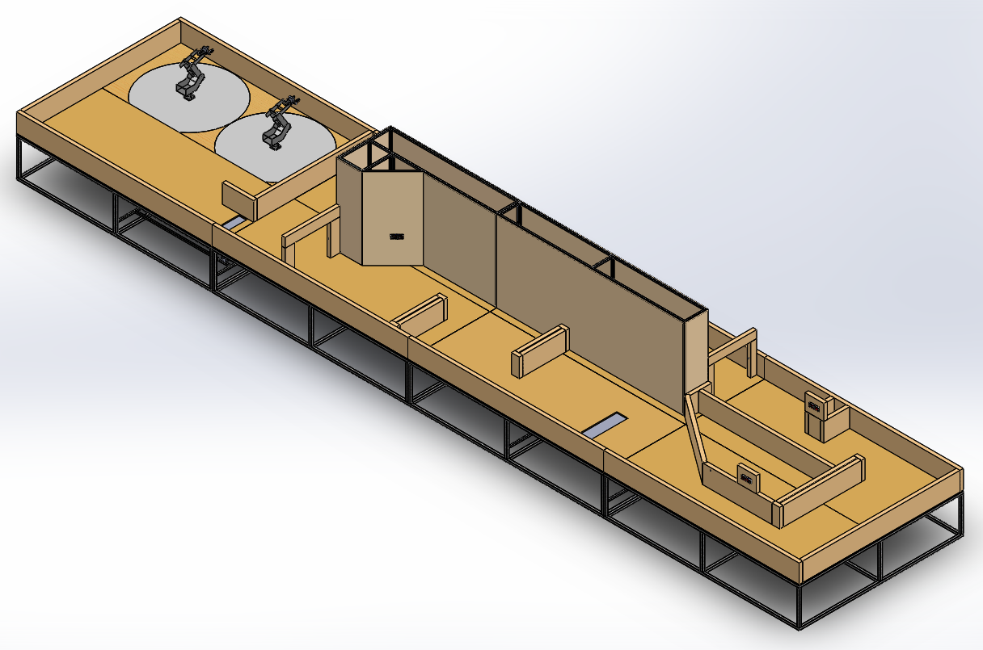

The 4WD power-up, when activated, will negate this noise and allow the visitor to smoothly drive their vehicle through the “off-road” area.

1. **Emergency** – There is one set off traffic lights on the race track (shown below). Visitors must stop at these lights when they are red, or they will lose points which negatively affect their final race score.



TRAFFIC LIGHTS

Activating the emergency power-up will allow visitors to pass through red traffic lights without penalty.

1. **Speed boost** – The speed boost can be activated at any time, providing the vehicle with a short-lived increase in speed.
2. **Short cut (portal)** – The first obstacle in the chicane (shown below) is a wall that can be lowered down into the track. The short cut power-up lowers this wall and allows the visitor to drive straight over it.



##### 

### Leaderboard

A leaderboard is displayed on a digital screen to the entry/exit of the Arcade gallery and will show the visitors’ names, final credit scores, and lap times.

#### Progress Timeline

A timeline against the southern wall of the Arcade galley detailing all of the work involved in Custom-Made.

#### Overhead projection of main platform

Suspended above the main platform will hang a screen onto which the camera feed of the three top down cameras will project.

#### Projection of vehicle POV feed

At the west end of the gallery will hang a screen onto which the feed from the vehicle’s POV camera will be projected.